GlobalBank CRM – Functional Use Cases

BUSINESS CONTEXT 1
GLOSSARY 2
ROLES 2
USE CASES 4
1) Greeter assigns customer to Officer 4
2) Officer receives customer 7
3) User searches customer 10
4) User browses customer data 12
5) Officer solves claim for undeliverable bank statement 17
6) Officer presents offer to customer and schedules appointment 20
7) System processes incoming e-mail according to customer portfolio 24
8) Officer checks budget status 30
9) Officer plans commercial actions 32
10) Officer browses pending tasks list 39
11) Officer plans meeting with customer 41
12) System displays opportunities related to a change address event 43
APPENDIX – Microsoft Outlook 45
DOCUMENT HISTORY 46

BUSINESS CONTEXT
The use cases in the current document are oriented to the development of Personal Banking.
In this case, the business profitability comes mainly from the systematic and sustained development of the commercial relationship with the customers, which is maintained through three basic factors:
- Assurance of differential levels of service, integrating the whole organization to this purpose
- High level of personalization, identifying the customer in every contact established through any of the bank’s communication channels
- Simple exploitation of different business opportunities, derived from the information the bank has of its customers
Nowadays, a sales budget on this type of banking market can only be accomplished through the Officer’s commercial actions agenda. Therefore, the business organization is centered mainly on contact management, both proactive and reactive, being a key aspect on the business development.
The immediate addressees of these use cases are the branch Officers, who must combine the planned contacts with customers, the prospects originated both from telemarketing actions and from the result of a media campaign, and the opportunities that are derived from the customer information, and transform them into business development contacts.
On another stage, these use cases could be extended to other commercial roles, like the ones for business banking, where the contact via e-mail is frequent and requires to be integrated with the tools that manage the relationship with customers.
Finally, and from our experience, we find that this model could also be applicable on other markets, like the ones responsible for the development of commercial relationships on massive consumption companies, where opportunities arise from the application of these concepts.
This solution aims to make compatible and highly efficient the communication management with customers via e-mail and the Officer’s daily schedule administration aligned to their business goals, as well as to get the best profit of the investments made on CRM solutions, believing that most of our company’s growth opportunities are originated both on the information we already posses from our customers and on the maximization of the success possibilities of the 15 minutes that a customer can dedicate us on each contact.

GLOSSARY
Activity Summary: log of all the contacts established with a customer through any communication channel, like e-mail, phone or meeting.
Customer portfolio: Officers are responsible for the relationship with customers that belong to their customer portfolio. Customers from a portfolio know their assigned Officer, and manage most of their interactions with the bank through this channel.
Visit: tracks the customer’s status and actions at the bank when a meeting with an Officer is requested.
The states that are part of the visit workflow are:
- Assigned To Officer: the customer has been assigned to an officer and is waiting to be called
- In Process: the customer is with the assigned Officer
- Cancelled: the visit was cancelled because the customer left the bank before the meeting took place
- Finished: the customer was received by the Officer and the meeting is over
The time elapsed between the states “Assigned To Officer” and “In Process”/”Cancelled” is the customer’s waiting time, and the time elapsed between the states “In Process” and “Finished” is the customer’s service time.
Cross selling indicator: this indicator is obtained by calculating the branch’s average quantity of products by customer.
Profitability indicator: this indicator represents the relation between incomes generated by the customer and his administration costs.

ROLES
Greeter: The Greeter is a role from a bank’s branch that has access to the complete customer information, like the Officer, but who is allowed to perform a more limited set of tasks.
His main task is to resolve the customer’s enquiries and requests when they are within his role’s authorized tasks; when he encounters a customer’s request that he can not resolve by himself, he assigns the customer to an Officer.

Officer: The Officer is a role from a bank’s branch that has access to the complete customer information. The main tasks he performs are:
- receives and answers customer enquiries
- opens new accounts
- promotes bank products and services
- identifies customer needs and refers them to appropriate banking services
- enters details in customers' accounts
- records transactions
- issues bank checks
- answers customers' enquiries regarding their accounts
- makes sure that accounts are conducted correctly

USE CASES
- Greeter assigns customer to Officer

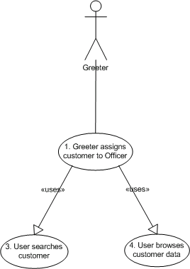

  - Actors:
    - Greeter
  - Description:
The purpose of this task is to provide the Greeter with means to assign a customer who has an enquiry or a request to a particular Officer.
The Greeter identifies the customer in the system by providing his first and last name or document type and number.
Once the customer is assigned to the requested Officer, a new visit is created with this information and the state “Assigned To Officer”. This interaction is registered in the Activity Summary.
  - Pre-conditions:
    - The customer is not associated to an Officer’s customer portfolio, but his products are registered at the current branch
    - The Greeter uses Outlook to assign a customer to an Officer.
  - Normal flow:
    - The Greeter searches customer (see Use Case 3)
    - The Greeter double-clicks customer, and customer data is displayed (see Use Case 4)
    - The Greeter clicks the “Assign To Officer” button from the toolbar

    - The system displays the “Assign Customer To Officer” form, which has the customer name field pre-populated, obtained from the Customer Data Form. The form will contain the following information:
      - Customer name
      - Branch officer’s availability: list of officers and number of customers in waiting list for each Officer
      - Contact reason: the contact reason field is divided into two levels of detail. The first level has a list of products, and the second level has the list of contact reasons for each product. The Greeter can also add other comments to the Officer in the “Comments” text field.

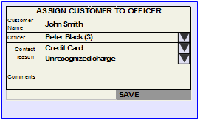

Contact reasons:

PRODUCT | REASON
Checkings Account | Opening request
Checkings Account | Change account information
Checkings Account | Claims
Checkings Account | Check book request
Checkings Account | Funds transfer request
Savings Account | Opening request
Savings Account | Close account
Savings Account | Change account information
Savings Account | Claims
Savings Account | Funds transfer request
Debit card | Card request
Debit card | Change card information
Debit card | Reset password
Debit card | Card replacement request
Debit card | Claims
Packs | Add packs and products
Packs | Remove packs and products
Packs | Add products to pack
Packs | Remove products from pack
Packs | Claims
Investment | Renewal of deposits on due date
Investment | Deposit cancellations
Investment | Bonds operations
Investment | Funds operations
Investment | Claims
Credit Card | Card request
Credit Card | Reset password
Credit Card | Unrecognized charges
Credit Card | Card replacement request
Credit Card | Claims
Services | Add service to direct debit
Services | Change service direct debit
Services | Remove service direct debit
Services | Stop debit
Services | Claims
Loans | Loan request
Loans | Change data
Loans | Cancel quota
Loans | Refinance loan
Loans | Claims
Insurance | Buy insurance
Insurance | Change data
Insurance | File a claim
Insurance | Supply insurance claim information
Insurance | Claims

    - The Greeter selects the Officer that the customer has requested from the list of officers displayed in the form (the number between parentheses represents the number of customers in the officer’s waiting list)
    - The Greeter browses the contact reasons lists and selects the appropriate product and reason according to the customer’s request. If necessary, the Greeter can add a comment to the Officer in the “Comments” textbox.
    - The Greeter clicks the “Save” button
    - The system creates a new visit with the state “Assigned To Officer” and saves the customer assignment to Officer information, registers this information in the Activity Summary and closes the form
  - Alternate flows:
    - Instead of double-clicking a customer to open the Customer Data Form, the user can assign a customer to an Officer by right-clicking the customer from the search results list and selecting the “Assign to Officer” option from the menu, which will open the “Assign Customer To Officer” form
    - If the Officer solicited by the customer is busy and already has customers in his waiting list, the Greeter can suggest another Officer who is available or has less customers in his waiting list, which the customer may accept or decline.

- Officer receives customer

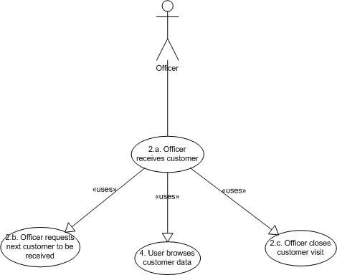

  - Officer receives customer
    - Actors:
      - Officer
    - Description:
The purpose of this task is to provide the Officer with complete customer information in order to be able to satisfy a customer’s requirement or enquiry.
    - Normal flow:
      - The Officer requests next customer to be received (see Use Case 2.b.)
      - The Officer browses customer data (see Use Case 4)
      - The Officer checks the customer’s information by going through the following sections in the Customer Data Form:
        - Reason of visit
        - News (to check if there are pending claims)
        - Opportunities
      - The Officer closes the contact with the customer (see Use Case 2.c.)
    - Alternate flows:
      - If the customer has left the bank before being called by the Officer, the Officer clicks the “Cancel” button from the Contact information section. The visit’s state is changed from “Assigned To Officer” to “Cancelled”. This information is registered by the system in the Activity Summary and the Customer Data Form is closed

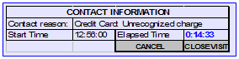

  - Officer requests next customer to be received
    - Actors:
      - Officer
    - Description:
The goal of this task is to obtain the next customer to be received by a particular Officer from the waiting customers list.
    - Pre-conditions:
      - The Officer does not have a visit in “In Process” state
    - Normal flow:
      - The Officer clicks the “Get Next Customer” button from the toolbar
      - The system changes the visit state from “Assigned To Officer” to “In Process”
      - The system displays the Customer Data Form of the first customer in the Officer’s waiting list, which is sorted by time of arrival, and disables the “Get Next Customer” button from the toolbar
    - Alternate flows:
      - If the Officer wants to see the complete list of waiting customers, he clicks the “Show Waiting Customers” button from the toolbar. The system displays the list of customers waiting to be received by the Officer, sorted by time of arrival

  - Officer closes customer visit
    - Actors:
      - Officer
    - Description:
This task’s main objective is to register in the Activity Summary that a contact was established and finished with a customer, as well as all the associated information with this event.
    - Normal flow:
      - The Officer clicks the “Close Visit” button from the Contact information section from the Customer Data Form
      - The system displays the Close Visit Form which has the customer name field pre-populated, obtained from the Customer Data Form. The form will contain the following information:
        - Customer name
        - Contact result: list of possible contact results. The Officer can also add other comments in the “Comments” text field.
The list of contact results is:
- Customer left
- Customer reassigned
- Visit ended

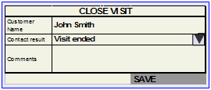

      - The Officer enters the required information and clicks the “Save” button
      - The system changes the visit’s state from “In Process” to “Finished”, registers this information in the Activity Summary and closes both the Activity Summary form and the Customer Data Form
    - Alternate flows: N/A

- User searches customer

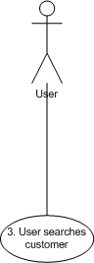

  - Actors:
    - User (E.g. Greeter, Officer)
  - Description:
The goal of this task is to provide the User with means to quickly identify a customer given his first and last name or document type and number. If more than one customer matches the search criteria, the User will be presented with a list of results and will have to ask for further information in order to uniquely identify the customer.
  - Normal flow:
    - The User opens the Customer Search Form by clicking the “Search Customer” button from the toolbar

    - The User inputs the search criteria, which can be:
      - customer’s first and last name or
      - customer’s document type and number
and clicks the “Search” button

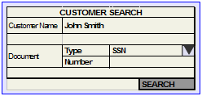

    - The system displays the customer that matches the search criteria. The customer information to be shown is:
      - First and Last Name
      - Document type and number
      - Address
      - Phone number

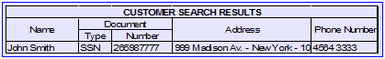

  - Alternate flows:
    - If more than one customer matches the search criteria, the system displays a list of customers and the User will have to ask for further information like address and phone number, which are included in the result list, in order to uniquely identify the customer

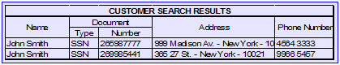

- User browses customer data

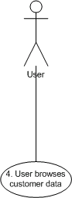

    - Actors:
      - User (E.g. Greeter, Officer)
    - Description:
The purpose of this task is to have a 360 degrees view on the customer providing the User with complete information on the customer including contact and demographic data, like first and last name, document type and number, address, phone number, e-mail, customer Opportunities, customer News, the list of the customer’s products and status, and the last n records from the Activity Summary.
    - Normal flow:
      - The system displays Customer Data Form with the customer information grouped in two tabs and different sections:

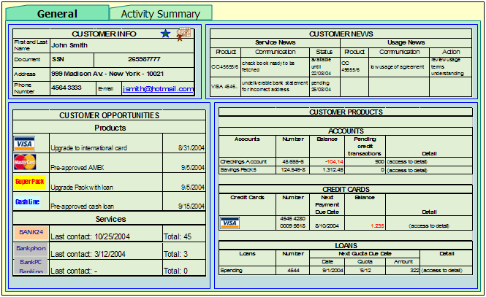

        - General tab
          - Customer info: this section displays the customer general information
            - First and last name
            - Document type
            - Document number
            - Address
            - Phone number
            - E-mail

There are two icons that visually display the following indicators:
: Cross selling indicator (see glossary)
: Profitability indicator (see glossary)

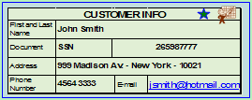

          - Customer Opportunities: this section displays a list of commercial opportunities related to the customer, which are obtained from the backend system according to his profile information (commonly as a result of a cross-selling operation in the CRM system); it is divided into Products and Services. The Products subsection includes available product offers or offers that were already informed to the customer but have not been accepted or declined yet. The Services subsection has information related to the contact channels: the last contact date and the number of contacts made through each channel (HomeBanking, PhoneBanking, etc.).

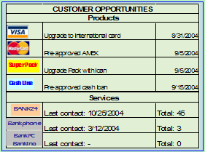

          - Customer News: this section displays a list of customer news, which are obtained from the backend system (e.g. CRM), like a notification when there is an unresolved claim or a payment due date; it is divided into Service News and Usage News.
Service News: these are transactional news originated in sale processes (for example, when a customer has pending documentation to hand in to open an account), in customer services (for example, when a customer has a checks book ready to be fetched), or in cash processes (for example, when an account has operation restrictions)
Usage News: these types of news are originated by the use of a product during a period of time which could derive in potentially risky or inefficient customer conduct. For example, an excessive use of an overdraft agreement or a high number of transactions through personalized channels.

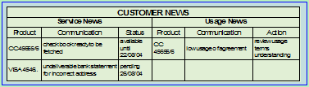

          - Customer Products: this section displays the list of products the customer has, which are obtained from the backend system, and each product’s current status

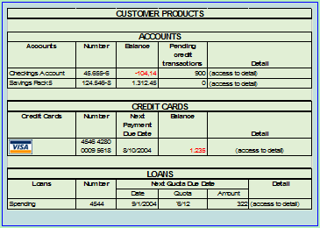

When an item from one of the Customer Data Form sections is selected, the Customer Products section is reduced to half of its size, and displays the products summary information. A new section, called the Display Detail Panel section, is displayed in the free space; the information displayed on this section depends on the type of the item selected.

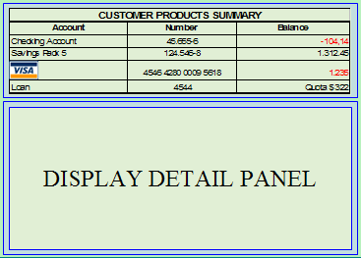

The sections should be loaded in the following order:
- General information
- Contact information
- Customer Opportunities
- Customer News
- Customer Products
- Display Detail Panel

          - Contact information
            - If current user is an Officer, and the Officer has a visit associated to current customer, the Opportunities section is reduced and this section displays:
              - Customer’s contact reason
              - Start Time
              - Elapsed Time
              - “Cancel” button
              - “Close Visit” button

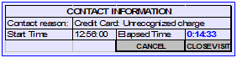

        - Activity Summary tab
          - Contact History: this section displays the last n contacts from the Activity Summary and includes a filter by date to enable custom searches. The information displayed is:
            - Search Filters
              - From date
              - To date
              - “Search” button
            - Contact date
            - Event number
            - Product
            - Reason
            - Officer
            - Status
            - “View Detail” button

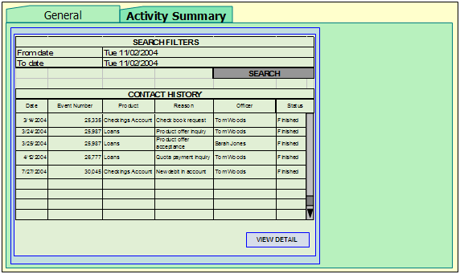

    - Alternate flows: N/A

- Officer solves claim for undeliverable bank statement

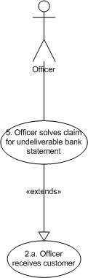

  - Actors:
    - Officer
  - Description:
The goal of this task is to provide the Officer with the means to identify a customer’s claim for an undeliverable bank statement, and proceed to solve it by changing the customer’s address.
The customer must provide one of the following documents to confirm the new address:
- Public service receipt
- AMEX, VISA or MC credit card statement from class A banks
- Rent contract
- Real estate ownership title
The states of a claim are:
  - Open
  - Processing
  - Closed
  - Normal flow (Extends Use Case 2.a at point 2.a.iii.(5)):
    - The Officer verifies that there is a claim for an undeliverable bank statement in “Open” state by going through the list of items in the Customer News section from the Customer Data Form
    - The Officer selects the corresponding claim from the list, which is of type “Undeliverable Bank Statement”
    - The system refreshes the Display Detail Panel section and displays the following information (the claim type is required to determine the information to be displayed in this section):
      - Claim description
      - “More Info” button: when clicked, the system opens a form with detailed information about the claim
      - “Change Address” button: when clicked, the system opens a form to change the customer’s address
      - “View Contacts” button: when clicked, the system displays a form with the list of contacts established with the customer related to the current claim

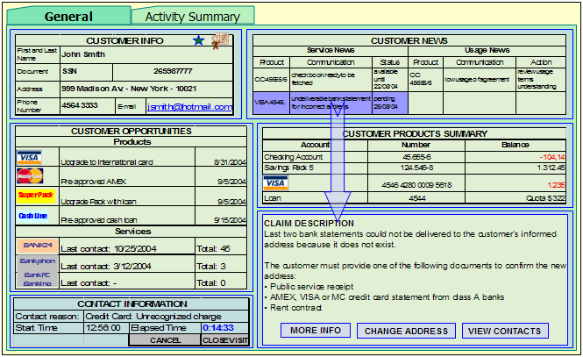

    - After having checked the customer’s documentation to confirm the new address, the Officer clicks the “Change Address” button
    - The system displays the Change Address Form, which has the customer name and address fields pre-populated, extracted from the Customer Data Form. The form will contain the following information:
      - Customer name
      - Customer address
      - Customer new address
      - “Save” button

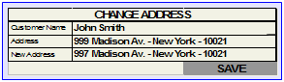

    - The Officer enters the customer’s new address and clicks the “Save” button
    - The system saves the customer’s new address, changes the claim state to “Closed”, and closes the Change Address Form
    - The system refreshes the Customer News section, where the closed claim should not be listed any more
  - Alternate flow: N/A

- Officer presents offer to customer and schedules appointment

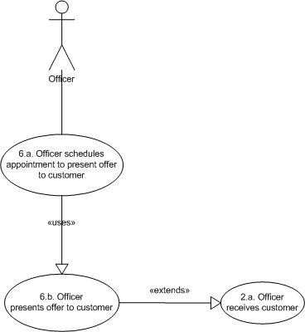

  - Officer schedules appointment to present offer to customer
    - Actors:
      - Officer
    - Description:
The purpose of this task is to present the Officer with the means to schedule an appointment with a customer to go over an offer in more detail.
For example, after presenting the offer to the customer, the customer shows interest in knowing more about it but does not have time at the moment.
    - Normal flow:
      - The Officer presents an offer to customer (see Use Case 6.b.)
      - The customer can’t go over the offer at the moment, but is interested in knowing more about it; the Officer suggests to set an appointment with the customer and clicks the “Schedule App.” button
      - The system opens the Appointment Form, which has the customer name and the offer description fields pre-populated extracted from the Customer Data Form. The form will contain the following information:
        - General tab: this tab has the appointment’s general information
          - Appointment subject
          - Customer name
          - Offer description
          - Start and end date and time

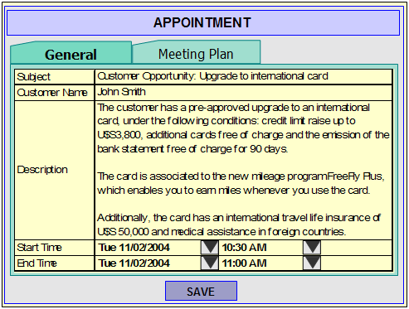

        - Meeting Plan tab: this tab is used when planning the meeting with the customer (see Use Case 11 for further reference)
          - Objective
          - Orientation
          - Conclusions
            - Achievements
            - Pending items
            - Issues

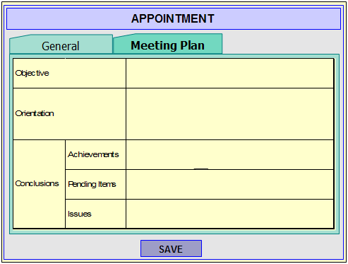

        - “Save” button
      - The Officer sets the requested date and time, and clicks the “Save” button
      - The system saves the information, changes the offer’s state from “Available” to “Interested”, and closes the Appointment Form
    - Alternate flows:
      - Instead of clicking the “Schedule App.” button, the Officer can add an appointment to review the offer with the customer by right-clicking the offer from the Opportunities list and selecting the “Schedule Appointment” option from the menu, which will open the Appointment Form
      - If the Officer double-clicks the customer at the Appointment Form, the system displays the Customer Data Form (see Use Case 4)
      - If the Officer clicks the “Show Customer Pane” button from the toolbar when editing an appointment, the system will display a right pane with the customer summary information.

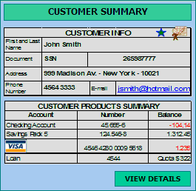

  - Officer presents offer to customer
    - Actors:
      - Officer
    - Description:
The purpose of this task is to present the Officer with all the necessary information to allow him to inform a particular customer about the available offers obtained from the backend system according to the customer’s profile.
The states of an offer are:
  - Available: the offer has not been presented to the customer yet
  - Interested: the offer has been presented to the customer, and is interested in knowing more about it
  - Not Interested: the offer has been presented to the customer, but has been declined
  - Accepted: the customer has accepted the offer
    - Normal flow (Extends Use Case 2.a. at point 2.a.iii.(5)):
      - The Officer verifies if the customer has available offers by going through the list of items in the Opportunities section from the Customer Data Form
      - The Officer selects an offer from the list
      - The system refreshes the Display Detail Panel section and displays the following information:
- Offer description
- “More Info” button: when clicked, the system opens a form with detailed information about the offer
- “Accept Offer” button: when clicked, the system opens a form to register the offer acceptance
- “Decline Offer” button: when clicked, the system changes the state of the offer to “Not Interested” and refreshes the Opportunities section, where the offer will not be listed any more
- “Schedule App.” button: when clicked, the system opens the Appointment Form (see Use Case 6.a.)

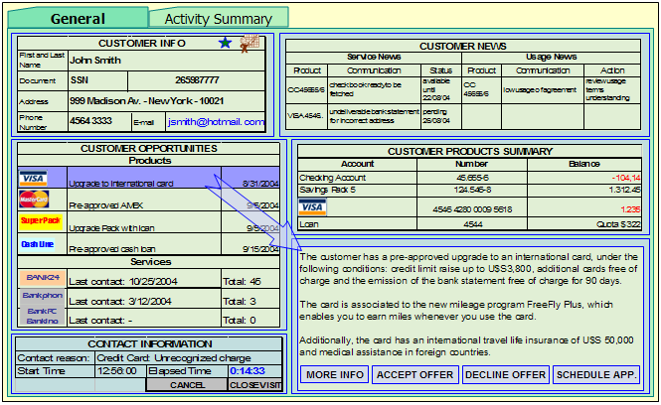

    - Alternate flows: N/A

- System processes incoming e-mail according to customer portfolio

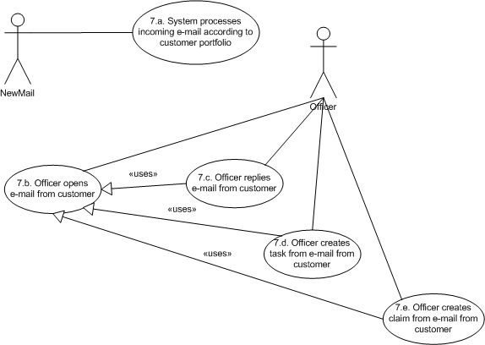

  - System processes incoming e-mail according to customer portfolio
    - Actors:
      - NewMail
    - Description:
The purpose of this task is to identify e-mails received from a customer that belongs to an Officer’s customer portfolio, in order to store it in the appropriate repository, register it in the Activity Summary and mark the mail for follow-up.
E-mails received from customers that belong to an Officer’s portfolio are automatically moved to an e-mail repository named “My Customers” that every Officer has for his assigned customers. Upon reception the e-mail is marked for follow-up and a reminder is associated to it, which will be displayed after n minutes. This is to ensure that the Officer will read the e-mail and take the required action.
The Officer has a special view that displays the list of all the e-mails marked for follow up, grouped by customer.
These e-mails are also copied to a centralized repository, and are registered in the customer’s Activity Summary.
    - Normal flow:
      - A new e-mail from a customer that belongs to the Officer’s customer portfolio is received
      - The system moves the received e-mail to the Officer’s mail repository named “My Customers”
      - The system marks the e-mail for follow-up and sets a reminder to process the mail after n minutes
      - The system copies the e-mail to a centralized repository and registers it in the customer’s Activity Summary
    - Alternate flows: N/A

  - Officer opens e-mail from customer
    - Actors:
      - Officer
    - Description:
The purpose of this task is to identify the opening of an e-mail received from a customer that belongs to an Officer’s customer portfolio and that is marked for follow-up, in order to provide the Officer with a customer information summary.
    - Normal flow:
      - The Officer clicks the “My Customers Pending E-mails” button from the toolbar
      - The systems displays the list of pending e-mails marked for follow-up from the “My Customers” repository
      - The Officer double-clicks an e-mail from the list
      - The system displays the e-mail with a summary of the customer’s information and a link to view details, which opens de Customer Data Form. The summary pane will display the following information:
        - Customer info (this is the same section displayed in the Customer Data Form)
        - Customer products summary (this is the same section displayed in the Customer Data Form, when section is minimized)

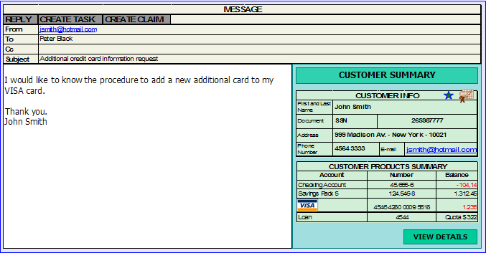

    - Alternate flows: N/A

  - Officer replies e-mail from customer
    - Actors:
      - Officer
    - Description:
The purpose of this task is to identify the reply of an e-mail received from a customer that belongs to an Officer’s customer portfolio and that is marked for follow-up, in order to copy the reply e-mail to a centralized repository and register the reply information in the customer’s Activity Summary.
    - Normal flow:
      - The Officer opens e-mail from customer (see Use Case 7.b.)
      - The Officer clicks the “Reply” button from the E-mail Form
      - The system opens the Reply E-mail Form, which has the To, Subject and Body fields pre-populated extracted from the original e-mail

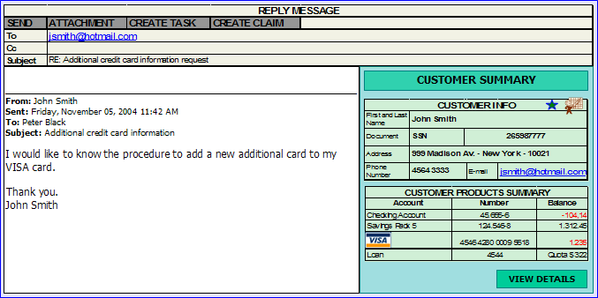

      - The Officer enters reply information and clicks the “Send” button
      - The system sends the e-mail and closes the Reply E-mail Form
      - The system moves the sent e-mail to the Officer’s mail repository named “My Customers”
      - The system copies the sent e-mail to a centralized repository and registers it in the customer’s Activity Summary
    - Alternate flows:
      - Instead of double-clicking an e-mail, the user can reply a message by right-clicking the e-mail from the “My customers” repository and selecting the “Reply” option from the menu, which will open the Reply E-mail Form
      - If the e-mail is marked for follow-up, this flag is removed when saving the reply

  - Officer creates task from e-mail from customer
    - Actors:
      - Officer
    - Description:
The goal of this task is to provide the Officer with means to create a task from an e-mail received from a customer that belongs to an Officer’s customer portfolio, in order to plan the following contact to be made with the customer or the next action to be taken.
    - Normal flow:
      - The Officer opens e-mail from customer (see Use Case 7.b.)
      - The Officer clicks the “Create task” button from the E-mail Form
      - The system opens the Task Form, which has the Related customer and Related e-mail fields pre-populated extracted from the e-mail and a link to the originating e-mail. The Description field is also pre-populated with the e-mail content. The form will contain the following information:
        - Subject
        - Description
        - Due date
        - Related customer
        - Related e-mail
        - “Open e-mail” button
        - “Save” button

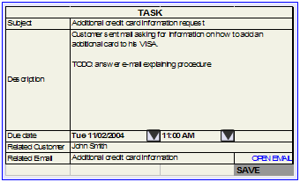

      - The Officer enters the following information:
        - Task subject
        - Task description (adds or modifies information)
        - Task due date
and clicks the “Save” button
      - The system saves the task and closes the Task Form
    - Alternate flows:
      - Instead of double-clicking an e-mail, the user can create a task by right-clicking the e-mail from the “My customers” repository and selecting the “Create task” option from the menu, which will open the Task Form
      - If the e-mail is marked for follow-up, this flag is removed when saving the task
      - If the Officer clicks the “Show Customer Pane” button from the toolbar when editing a task that has a related customer, the system will display a right pane with the customer summary information.

  - Officer creates claim from e-mail from customer
    - Actors:
      - Officer
    - Description:
The goal of this task is to provide the Officer with means to create a claim from an e-mail received from a customer that belongs to an Officer’s customer portfolio.
    - Normal flow:
      - The Officer opens e-mail from customer (see Use Case 7.b.)
      - The Officer clicks the “Create claim” button from the E-mail Form
      - The system opens the Claim Form, which has the Related customer and Related e-mail fields pre-populated extracted from the e-mail and a link to the originating e-mail. The Description field is also pre-populated with the e-mail content. The form will contain the following information:
        - Subject
        - Description
        - Date
        - Status
        - Type
        - Related customer
        - Related e-mail
        - “Open e-mail” button
        - “Save” button

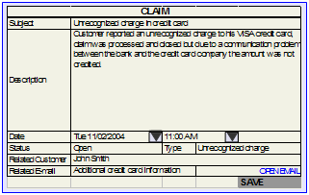

      - The Officer enters the following information:
        - Claim subject
        - Claim description (adds or modifies information)
        - Claim date
        - Claim status
        - Claim type
and clicks the “Save” button
      - The system saves the claim and closes the Claim Form
    - Alternate flows:
      - Instead of double-clicking an e-mail, the user can create a claim by right-clicking the e-mail from the “My customers” repository and selecting the “Create claim” option from the menu, which will open the Claim Form
      - If the e-mail is marked for follow-up, this flag is removed when saving the claim
      - If the Officer clicks the “Show Customer Pane” button from the toolbar when editing a claim, the system will display a right pane with the customer summary information.

- Officer checks budget status

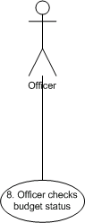

  - Actors:
    - Officer
  - Description:
The purpose of this task is to provide the Officer with means to quickly identify and understand his budget status using color indicators, and also allow him to look at the details of each indicator.
The officers’ incentives program is based on the level of accomplishment of the commercial budget; the Officer should aim to achieve a balanced level of satisfaction of all the products included in the budget. There is also a higher reward if the whole branch fulfills the global budget.
In this case, indicators are grouped by product in the following categories: packs, loans, credit cards and insurance.
120% is considered the maximum value for the recognition of accomplishment of the month in course. All products weigh up equally for the general progress totals.
Proactivity: relation between number of contacts made vs. number of contacts expected. The expected number of contacts to be made by an Officer is obtained from the relation between the Officer’s total available time, the average contact time and a productivity index.
Effectiveness: relation between sales made and promotional personal contacts established
Precision: percentage of approved sale records without data errors or formal observations
  - Pre-conditions:
    - The Officer must have a commercial budget assigned.
  - Normal flow:
    - The Officer opens the dashboard by clicking the “Dashboard” button from the toolbar
    - The system displays the dashboard, with the following information in the Commercial Budget tab:
      - General information
        - Branch, Region, Manager name, Regional manger name, Officer name, Employee file number, Seniority in position, Seniority in branch, Average number of contacts per day, Proactivity percentage, Effectiveness percentage and Precision percentage.
      - Budget information
        - Individual budget accomplishment
          - Up to current date: average between product’s accomplishment percentage
          - Projected: projected percentage of accomplishment
        - Status indicators for each product (budget, achievement, difference between budget and achievement, accomplishment percentage and assigned prospects)

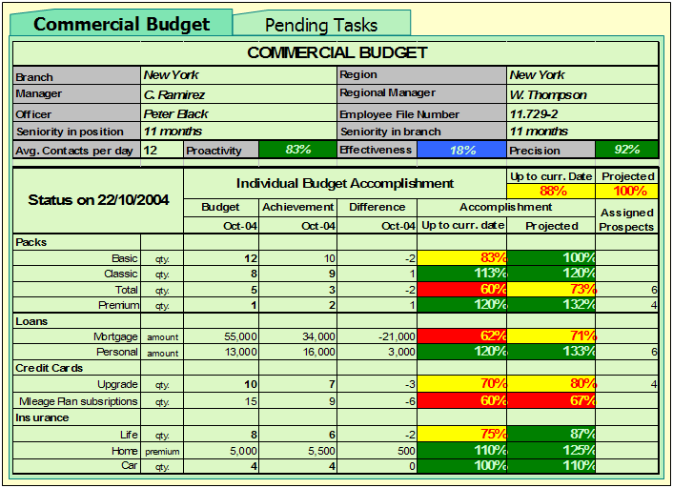

  - Alternate flows: N/A

- Officer plans commercial actions

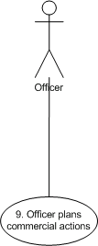

  - Actors:
    - Officer
  - Description:
The purpose of this task is to provide the Officer with means to plan the commercial actions for his following working week based on the level of accomplishment of his budget and the status of his in progress commercial actions. To add new commercial actions, the Officer selects prospects from a list of customers with available opportunities, and then creates commercial actions to contact them and present them with the opportunity. This task is usually done by the officer at the end of the working week.
The states of an opportunity are:
- Available: the opportunity is available to be presented to the customer
- Assigned: the opportunity is assigned to an Officer
- Planned: the opportunity is assigned to an Officer and is associated to a commercial action
- Finished: the opportunity has been presented to the customer and has been accepted
- Cancelled: the opportunity has been presented to the customer but is not interested
The states workflow of an opportunity is:
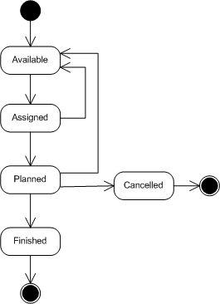

  - Pre-conditions:
    - The opportunities must exist as a result of the cross-selling procedure completed by the backend systems or the input of other channels (for example, telemarketing).
    - The Officer must have a commercial budget assigned.
  - Normal flow:
    - The Officer clicks the “View Opportunities” button from the toolbar
    - The system displays the list of opportunities for the customers from the current branch that are not already assigned to another officer. The information displayed is:
      - Officer budget status summary
        - Individual budget accomplishment
          - Up to current date: average between product’s accomplishment percentage
          - Projected: projected percentage of accomplishment
        - Status indicators for each product (budget, achievement, difference between budget and achievement, and assigned prospects)
      - Opportunities
        - Opportunity description
        - Customer information
          - Name
          - Document type and number
          - Phone number
        - Customer status
          - Opportunities
            - Products
            - Services
          - News
            - Service
            - Usage
        - Last contact with client
          - Date
          - Reason

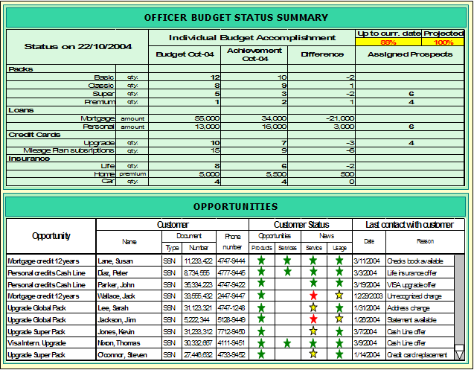

The stars represent the degree of importance of each opportunity, the services usage and the news priority. This information is provided by the backend systems, where it is calculated on the cross-selling process or it is entered manually by a backend user.
    - The Officer goes through the list and selects a prospect by right-clicking the opportunity from the list and selecting the Add to My Opportunities option from the menu
    - The system assigns the selected opportunity to the Officer and refreshes the list of opportunities, where the assigned opportunity should not be listed any more and the number of assigned prospects should be increased in the corresponding product
    - The Officer clicks the “View My Opportunities” button from the toolbar
    - The system displays the list of opportunities that have been assigned to the officer, and their status. The information displayed is:
      - Officer budget status summary
        - Individual budget accomplishment
          - Up to current date: average between product’s accomplishment percentage
          - Projected: projected percentage of accomplishment
        - Status indicators for each product (budget, achievement, difference between budget and achievement, and assigned prospects)
      - My Opportunities
        - Status
        - Opportunity description
        - Customer information
          - Name
          - Document type and number
          - Phone number
        - Customer status
          - Opportunities
            - Products
            - Services
          - News
            - Service
            - Usage
        - Last contact with client
          - Date
          - Reason

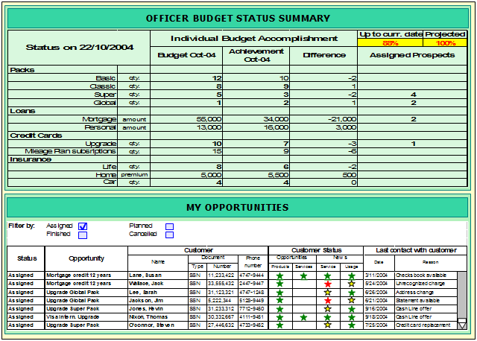

The stars represent the degree of importance of each opportunity, the services usage and the news priority. This information is provided by the backend systems, where it is calculated on the cross-selling process or it is entered manually by a backend user.
    - The Officer clicks the “Assigned” checkbox from the filter options
    - The system displays the list of opportunities in “Assigned” state
    - The Officer goes through the list of opportunities and creates a task to contact a customer to present him the opportunity by right-clicking an opportunity from the list and selecting the Create Commercial Action option from the menu
    - The system displays the Commercial Action Form, with the Related customer name and Related opportunity fields pre-populated. The form will display the following information:
      - Subject
      - Description
      - Due Date
      - Status
The states of a commercial action are:
        - Pending: the commercial action has not been started yet
        - Scheduled: the commercial action has been scheduled
        - Finished: the commercial action has been completed. When this state is assigned to a commercial action, the system must change the state of the related opportunity to “Finished”
        - Cancelled: the commercial action has been cancelled. When this state is assigned to a commercial action, the system must change the state of the related opportunity to “Assigned”
      - Related Customer
      - Related Opportunity
      - “Open Opp.” link to open related opportunity
      - “Schedule Appointment” button
      - “Save” button

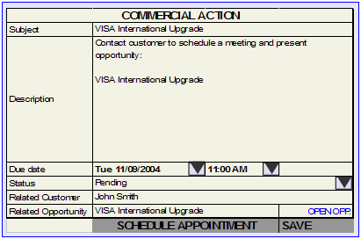

    - The Officer inputs the task subject, description and due date. The status is set to Pending
    - The Officer clicks the “Save” button
    - The system saves the task information, updates the opportunity state from Assigned to Planned, adds this information to the Activity Summary and closes the Commercial Action Form
    - The system refreshes the list of assigned opportunities, where the previous opportunity should have its state updated
  - Alternate flows:
    - If the Officer has reached the maximum number of opportunities assigned to him in a non-ending state (Assigned, Planned), the system displays an alert message informing this situation and does not assign him the selected opportunity.
    - If the Officer clicks the “Show Customer Pane” button from the toolbar when editing a commercial action, the system will display a right pane with the customer summary information.

    - If the selected opportunity’s state is “Planned” or “Finished”, the system will not display the Create Commercial Action option in the right-click menu
    - If the Officer wants to create a commercial action from an opportunity without going through the step of adding it to the list of My Opportunities first, he selects the “Create Commercial Action” option after right-clicking the opportunity. The system will automatically assign the opportunity to the Officer and change its state to Assigned, and then open the Commercial Action Form.
    - If the Officer wants to schedule an appointment from the commercial action, he can click the “Schedule Appointment” button from the Commercial Action Form, and enter the appointment’s date on the Appointment Form displayed by the system
    - If the Officer is working offline when planning his commercial actions, the system will add a “Not Synchronized” mark to the new or modified opportunities assigned to the Officer. When reconnected, the system will automatically synchronize the marked opportunities and when this process is finished remove this mark from those items. When working offline, the Officer can only view the opportunities that were assigned to him.
    - If the Officer is working offline when planning his commercial actions, the system will add a “Not Synchronized” mark to the new or modified commercial actions. When reconnected, the system will automatically synchronize the marked commercial actions and when this process is finished remove this mark from those items. When working offline, the Officer can only view the opportunities that were assigned to him.
    - If the Officer wants to create an opportunity to later transform into a commercial action, he can do so by clicking the “New Opportunity” button from the toolbar, when reviewing the list of My Opportunities. This opportunity will be created with Assigned status and will be associated to the Officer.
- Officer browses pending tasks list

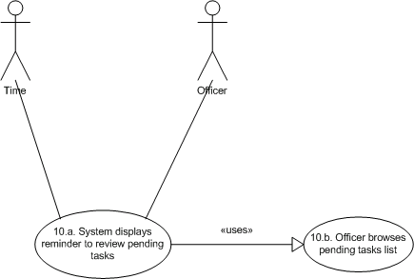

  - System displays reminder to review pending tasks
    - Actors:
      - Time
      - Officer
    - Description:
The purpose of this task is to remind the Officer to go through his list of pending tasks. This reminder is displayed every working day at the end of the day.
    - Pre-conditions: N/A
    - Normal flow:
      - At 16:00, the system displays the Reminder Form with the message “Review pending tasks list” and a button to display the list

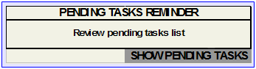

      - The Officer clicks the “Show Pending Tasks” button
      - The system displays the “Pending Tasks” tab from the Dashboard
      - The Officer browses the pending tasks list (see Use Case 10.b)
    - Alternate flows: N/A

  - Officer browses pending tasks list
    - Actors:
      - Officer
    - Description:
The purpose of this task is to provide the Officer with means to go over his pending tasks in order to complete them or reassign them to the following day.
    - Pre-conditions: N/A
    - Normal flow:
      - The Officer selects the “Pending Tasks” tab from the Dashboard
      - The system displays the Officer’s list of pending tasks, which includes:
        - E-mails marked for follow-up
        - Tasks not completed
        - Commercial actions in Pending state

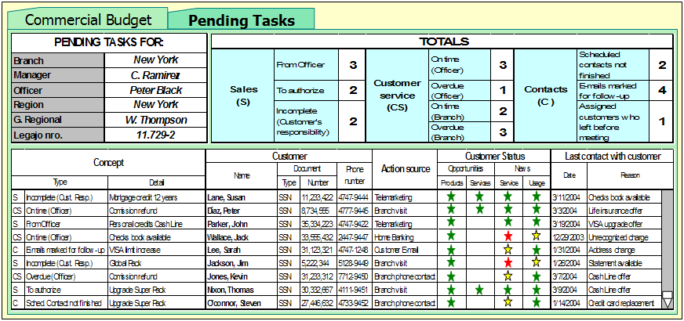

The stars represent the degree of importance of each opportunity, the services usage and the news priority. This information is provided by the backend systems, where it is calculated on the cross-selling process or it is entered manually by a backend user.
      - The Officer double-clicks a pending task
        - If the pending task is an e-mail
          - The system displays the E-mail Form
        - If the pending task is a task
          - The system displays the Task Form
        - If the pending task is a commercial action
          - The system displays the Commercial Action Form
    - Alternate flows: N/A

- Officer plans meeting with customer

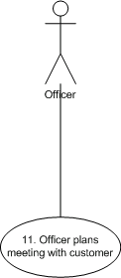

  - Actors:
    - Officer
  - Description:
The goal of this task is to provide the Officer with means to plan a scheduled meeting with a customer, reviewing the customer’s information and taking notes on how to conduct the meeting.
  - Pre-conditions: N/A
  - Normal flow:
    - The Officer clicks the “View Appointments” button from the toolbar
    - The Officer right-clicks a future appointment with a customer from the list, and selects the Plan Meeting option from the menu
    - The system displays the Meeting Plan Form, which has the following information:
      - Customer general information
      - Opportunities
      - News
      - Products Summary
      - Contact History
      - Meeting Plan
        - Objective
        - Orientation
        - Conclusions
          - Achievements
          - Pending items
          - Issues

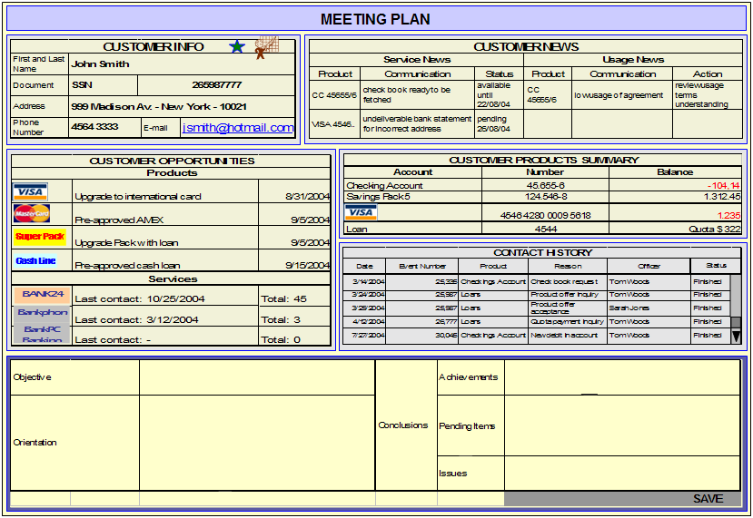

    - The Officer enters the required information on the Objective and Orientation fields at the Meeting Plan section and clicks the “Save” button
    - The system saves the appointment’s meeting plan information, adds this information to the Activity Summary and closes the Meeting Plan Form
  - Alternate flows:
    - The Officer can also access the meeting plan by double-clicking an appointment and selecting the Meeting Plan tab
    - If the Officer has already completed the meeting with the customer, he can enter the required information on the Conclusions fields

- System displays opportunities related to a change address event

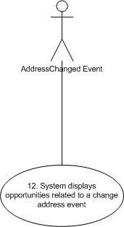

  - Actors:
    - AddressChanged Event
  - Description:
Certain types of events are related to different opportunities. When one of these events is captured by the system, it displays the list of opportunities available to the customer related to the occurred event.
The goal of this task is to present the Officer with a list of opportunities related to a change address event available to the customer (for example, house insurance, presuming that the customer has moved to a new house).
  - Pre-conditions: N/A
  - Normal flow:
    - An AddressChanged event occurs
    - The system displays the Opportunities Alert Form, which includes a list of available opportunities for the customer related to the AddressChanged event

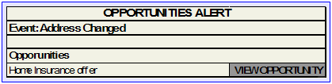

  - Alternate flows:
    - If the address is being changed from a Change Address Form, the system displays the list of opportunities inside the form, like a task pane located at the right

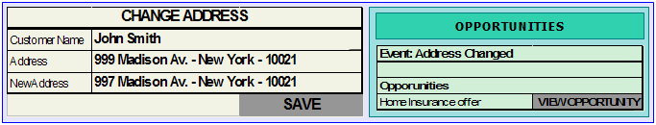

APPENDIX – Microsoft Outlook

The following folder arrangement is proposed in order to use Microsoft Outlook as an interface to interact with the backend CRM system.

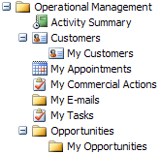

  - Operational Management

This folder groups all CRM related folders. Its Home Page should be changed so that it displays the Dashboard page when clicked (like the Personal Folders item displays the Outlook Today page).
  - Activity Summary

The Activity Summary items could be displayed using the Journal as an interface and retrieving the information from the CRM. Different Journal views could be defined to display the Activity Summary information by type of contact, by customer, by product, etc.

This folder could be synchronized to work offline.
  - Customers

This folder contains the customers that belong to the Officer’s bank branch.

The search form could be implemented as a task pane that is displayed when positioned in Customers folder. The search results could be displayed using custom views for the contacts folder.

To get the list of waiting customers, a view could be defined that filters contacts that have a visit in “Assigned To Officer” state and that is associated to current Officer.

The contact item should have a new option in the right-click menu: “Assign to Officer”, to be displayed when a customer does not already have a visit associated.

This folder could be synchronized to work offline.
  - My Customers

This folder contains the customers that belong to the Officer’s customer portfolio.

This folder could be synchronized to work offline.
  - My Appointments

This folder has the Officer’s list of appointments with customers obtained from the CRM backend system. They could be displayed as Outlook Appointments.

This folder could be synchronized to work offline.
  - My Commercial Actions

This folder contains a list of the commercial actions associated to current Officer. Different views could be defined to filter this list by status. Overdue commercial actions could be displayed in red.

This folder could be synchronized to work offline.
  - My E-mails

This folder contains the e-mails received from customers that belong to the Officer’s customer portfolio. Different views could be created to filter them by follow-up status.

This folder could be synchronized to work offline.
  - My Tasks

This folder contains the task items related to bank customers or duties.

This folder could be synchronized to work offline.
  - Opportunities

This folder contains the list of opportunities available. Different views could be defined to list opportunities by product, by customer or by customer status.
  - My Opportunities

This folder contains the list of opportunities that have been assigned to current Officer. Different views could be defined to filter this list by the opportunities’ status.

This folder could be synchronized to work offline.

DOCUMENT HISTORY

Author | Date | Comment
Gustavo Calveiro | 25-Oct-2004 | Business Cases
Wilson Chiesa | 25-Oct-2004 | Business Cases Reviewing
Lourdes Llambías | 3-Nov-2004 | Functional Use Cases – Part I
Wilson Chiesa | 3-Nov-2004 | Functional Use Cases Reviewing – Part I
Lourdes Llambías | 12-Nov-2004 | Functional Use Cases – Part II
Wilson Chiesa | 15-Nov-2004 | Functional Use Cases Reviewing – Part II

